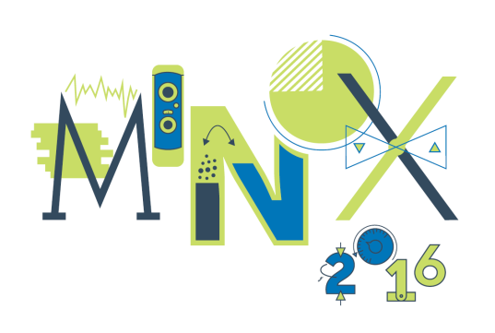
APPLICATION FORM
6th INTERNATIONAL INVENTION & INNOVATION EXHIBITION
MINOX 2016
7-8 OCTOBER 2016
RIGA, LATVIA

Application has to be submitted by 15 August 2016. Participation at the Exhibition is free of charge for foreign applicants. Participants have to cover their own travel and hotel expenses.

Inventor

1.* Name (First, Last)

2.* Do you represent any organization or company?
Yes/No
If yes, please write the name of the organization/company

3.* Country

4.* Title of the invention

5. Short description of invention (up to 1000 characters, the text will be included in the catalogue of the exhibition)

6. Number of patents or industrial design of this invention (if applicable)

7. What will you present at the exhibition? (model, prototype, device, poster, products, other - please, clarify)

8. What is the objective of your participation in this exhibition? (to find a cooperation partner, other - please, clarify)

9.* Would you like to participate in a business program? (selected b2b meetings on 7 October from 9 to 11 am)
Yes/No

10. Photo of the author (to be used in the catalogue of the exhibition) - send by email to info@connectlatvia.lv.

11. Photo of the invention (to be used in the catalogue of the exhibition) - send by email to info@connectlatvia.lv.

12. Contact information
* Name (First, Last)
Telephone
* E-mail
Website
Other

13.* Do you need a visa to come to Latvia?
Yes/No

14. The table size needed for your exhibition stand (in meters m). Maximum area for one inventor is 2 m. If you have special requirements, please send us email to info@connectlatvia.lv.

15. Your comments and questions

Send filled application by email to info@connectlatvia.lv.

Thank you for application! After receiving your application, we will contact you within two weeks.
If you have any questions, please e-mail us: info@connectlatvia.lv or call + 371 26220240 (Elmars Baltins, in English) or + 371 29258566 (Ivans Grinevics, in German, Polish and Russian).

